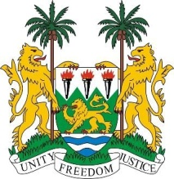
SIERRA LEONE
25th Session of the UPR

HUNGARY

STATEMENT BY SIERRA LEONE

4 May 2016

Mr President,

Sierra Leone welcomes the delegation of Hungary and thanks them for their update.

It is noteworthy that Hungary has implemented a second Action Plan relating to the promotion of the human rights of the Roma people. Hungary also contributed financially to the OHCHR between 2011 and 2015 and has a standing invitation to special procedures mandate holders.

My delegation would however encourage Hungary to incorporate targeted strategies aimed at better ensuring the participation of women of ethnic minorities, and to raise the age of criminal responsibility above 12.

While noting that Hungary has been severely affected by the migration crisis, my delegation urges Hungary to ensure that the need to protect its national borders does not ignore the fundamental responsibility to protect the human rights and fundamental freedoms of all persons and that a more humane asylum-seeking process, that respects the principle of non-refoulement, is maintained.

My delegation has the following recommendations:

- Ratify the ICPPED.
- Submit overdue reports to the Human Rights Committee, CESCR and CAT.
- Implement strategies aimed at tackling hate speech and xenophobia in all its forms.
- Establish a law to criminalise all forms of violence against women.

In conclusion, Sierra Leone wishes Hungary a successful UPR.

Thank you, Mr President.

